**The Department of Health and Exercise Science Presents:**

**Keeping it Simple” is not Simple!**

***The complexities of impactful performance***

***interventions for Mixed Martial Arts***

**Wednesday April 7, 2021**

**2:00-3:30 (online via ZOOM)**

**Guest Speaker: Dr Duncan French**

Dr Duncan French is the Vice President of Ultimate Fighting Championship Performance. With over 18 years of experience as a high-performance specialist, he has trained both amateur and professional athletes at the IAAF World Championships, Commonwealth Games, World Boxing Amateur Championships, Pan-American Games, and Olympic Games. He obtained his PhD in Exercise Physiology from the University of Connecticut and has authored numerous scientific manuscripts.

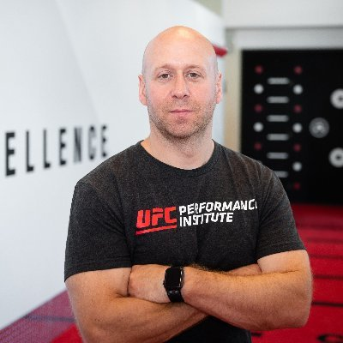

Conference Registration (due before April 2nd to avoid $2 late fee):

TNCJ student $5

0.5 HES conference credits